**Important portion for ESE**

**Type I**

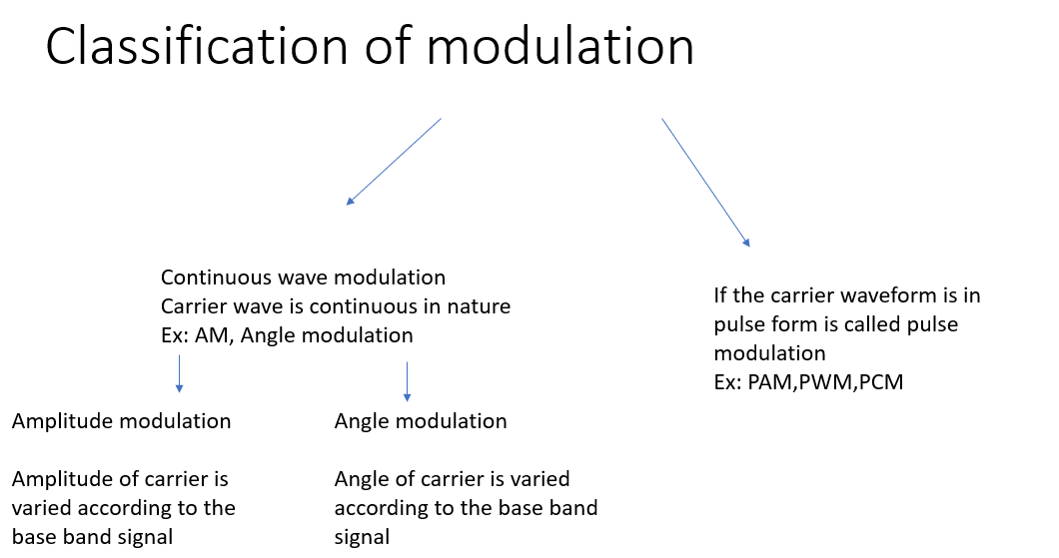

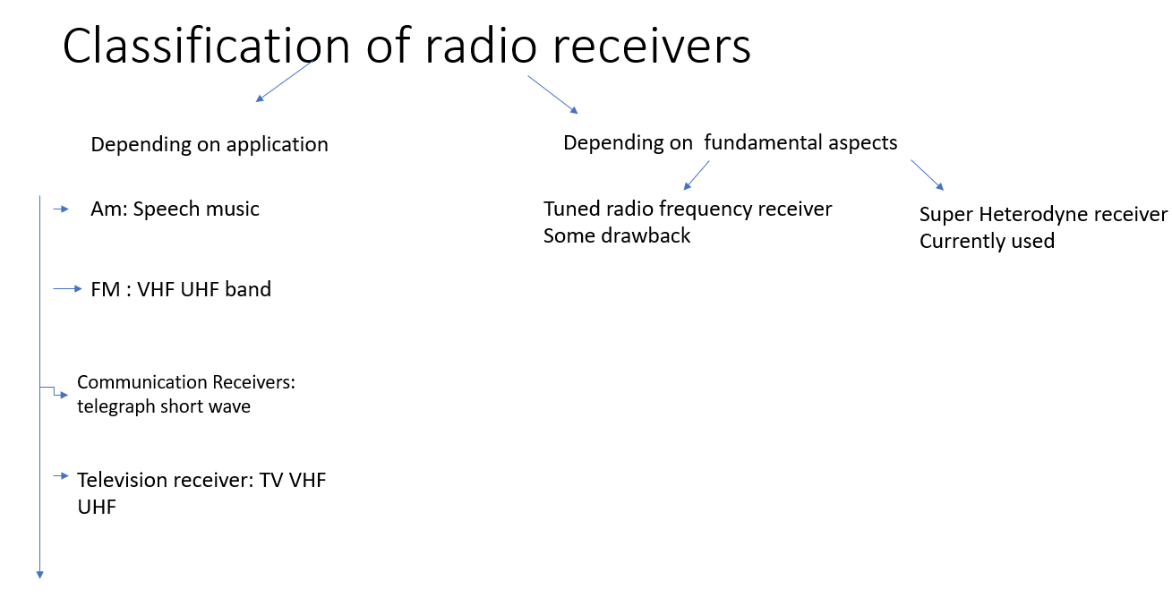

Sampling Theorem

* The statement of sampling theorem can be given in two parts as:
* (i) A band-limited signal of finite energy, which has no frequency-component higher than fm Hz, is completely described by its sample values at uniform intervals less than or equal to 1/ 2fm second apart.
* (ii) A band-limited signal of finite energy, which has no frequency components higher than fm Hz, may be completely recovered from the knowledge of its samples taken at the rate of  2fm samples per second.
* The first part represents the representation of the signal in its samples and minimum sampling rate required to represent a continuous-time signal into its samples.
* The second part of the theorem represents reconstruction of the original signal from its samples. It gives sampling rate required for satisfactory reconstruction of signal from it samples.
* Combining the two parts, the sampling theorem may be stated as under:
* ‘‘A continuous-time signal may be completely represented in its samples and recovered back if the sampling frequency is fs≥ 2fm. Here fs is the sampling frequency and fm is the maximum frequency present in the signal’’.

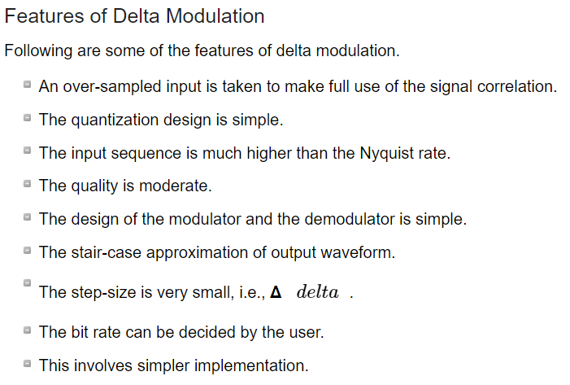

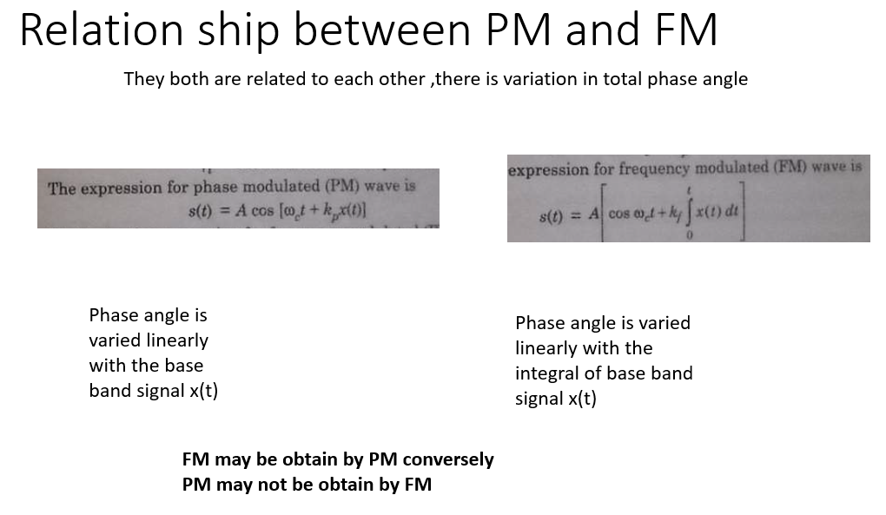

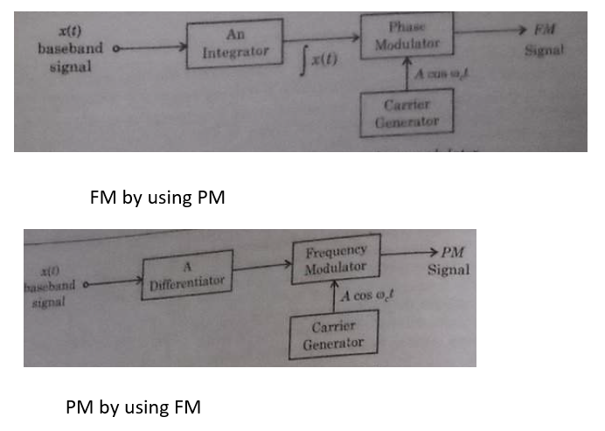

* Relation between PM and FM
* The change in phase, changes the frequency of the modulated wave. The frequency of the wave also changes the phase of the wave. Though they are related, their relationship is not linear. Phase modulation is an indirect method of producing FM. The amount of frequency shift, produced by a phase modulator increases with the modulating frequency. An audio equalizer is employed to compensate this.

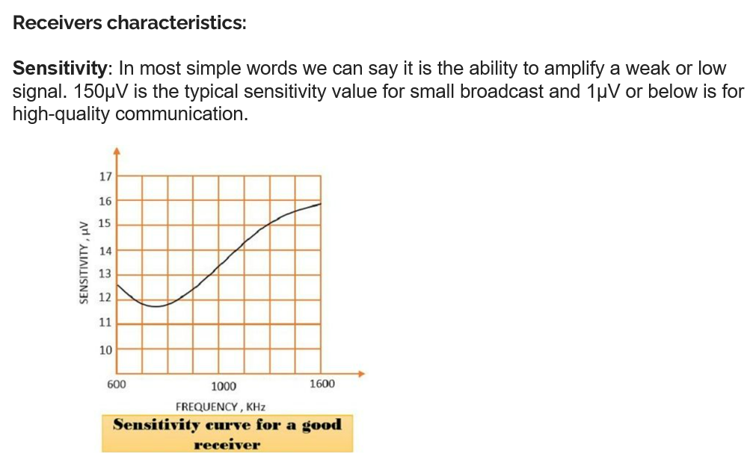

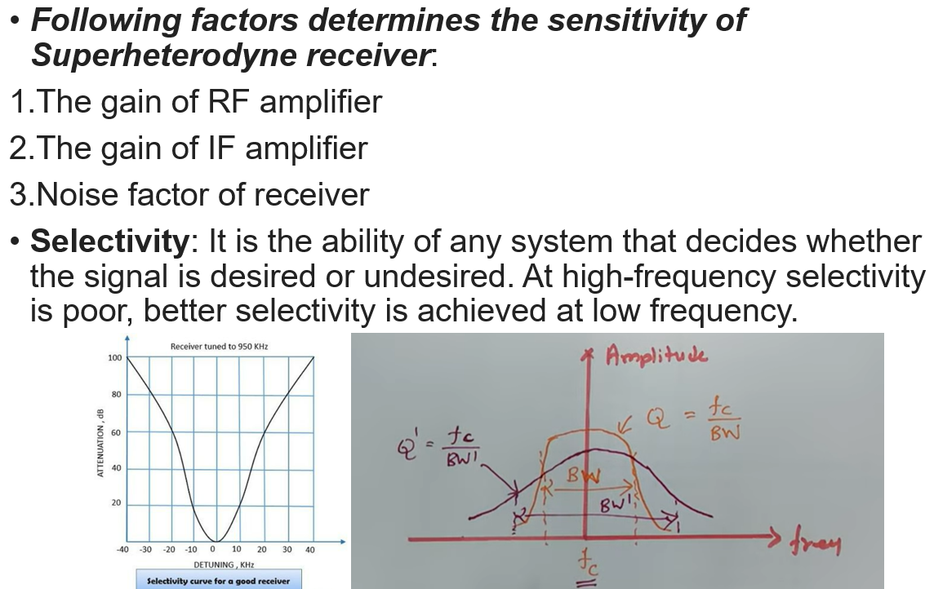

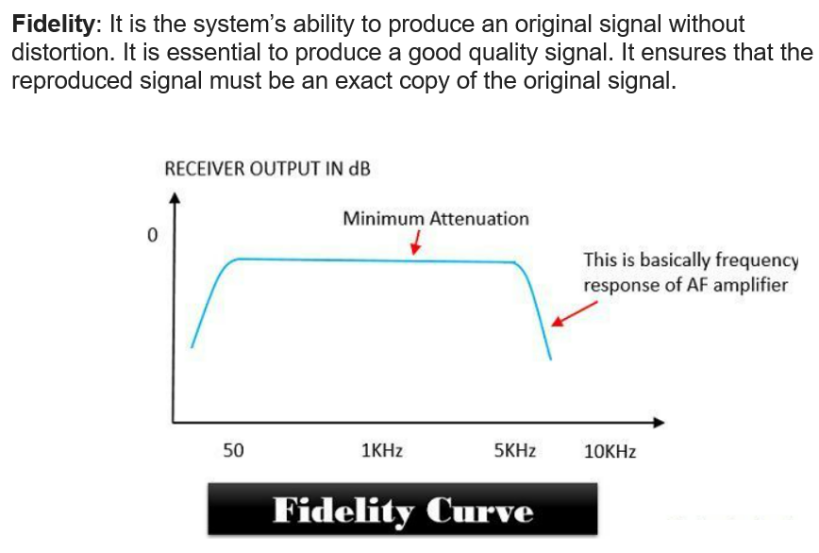

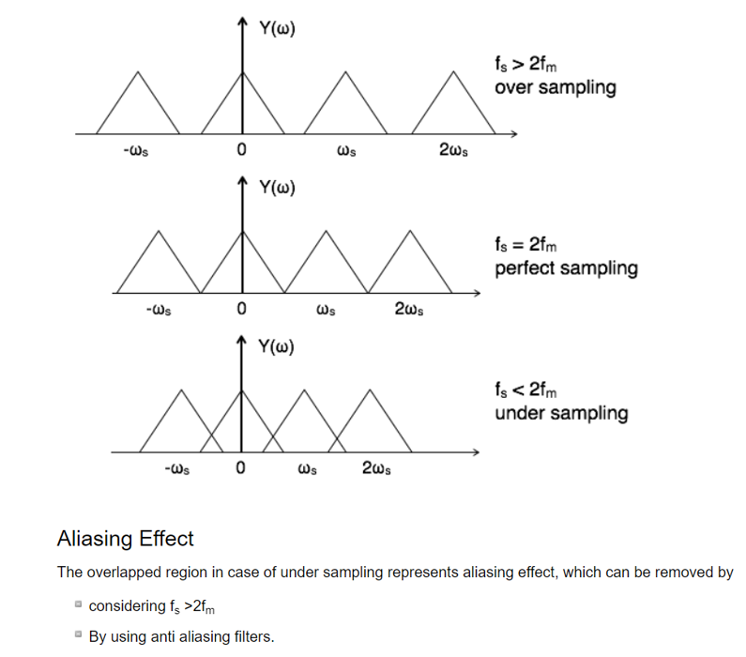

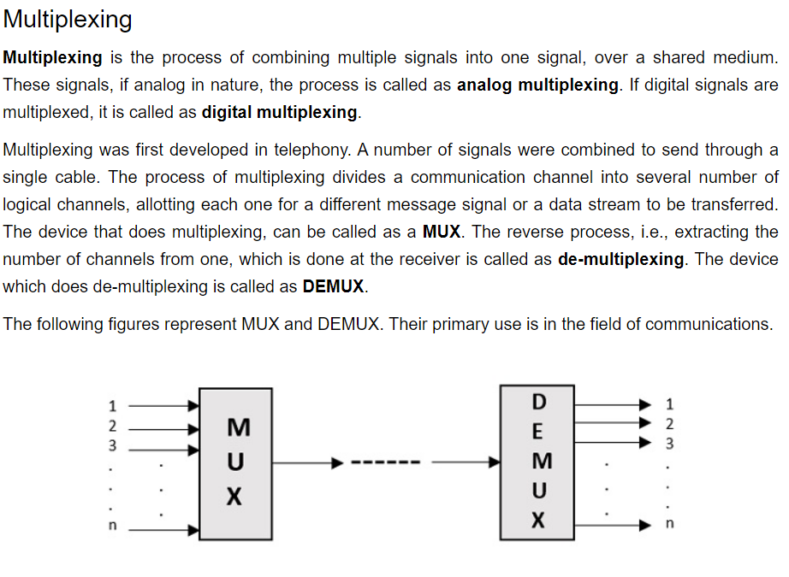

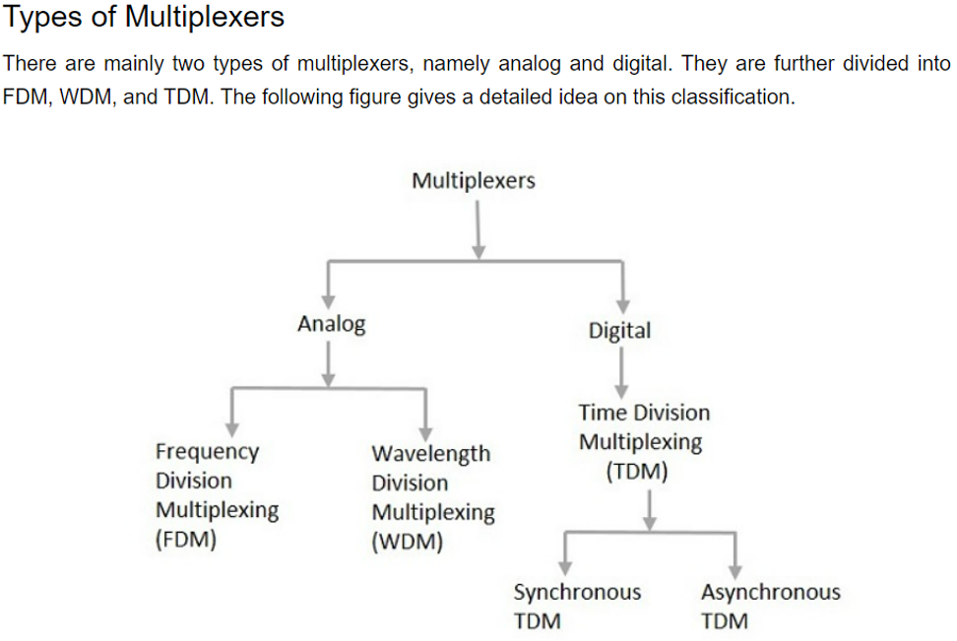

Linear and non Linear modulation

* Incase of AM modulation sideband follows the principle of superimposition , thus if signal x1(t) and x2(t) give rise to side band Φ1 and Φ2 respectively, the side band created by composite signal x1(t)+x2(t) will be Φ1+ Φ2
* There is no intermodulation or cross-product side band as we observe in FM ,for this reason AM is called linear liner type of modulation
* Linear modulation leads itself easily to mathematical manipulation and generalization the spectrum of modulating signal
* The spectrum of two modulating signal due to sum of two modulating signal can be found by calculating by spectrum due to each individual signal and then adding them together
* This is very useful in noise calculation in communication system
* For liner modulation system the effect of additive notice over the channel can be calculated by assuming the signal to be zero
* For this reason we are interested in approximating nonlinear modulation by linear model
* This is anlog to the case of system analysis where one can approximate a nonlinear system to the linear one over a limited range of signal amplitude
* Linear modulation techniques are used in most wireless LAN products
* whereas nonlinear techniques are used in most cellular and wide area wireless data systems.
* PLL FM demodulator design considerations
* When designing a phase locked loop system for use as an FM demodulator, one of the key considerations is the loop filter. This must be chosen to be sufficiently wide that it is able to follow the anticipated variations of the frequency modulated signal. Accordingly the loop response time should be short when compared to the anticipated shortest time scale of the variations of the signal being demodulated.
* A further design consideration is the linearity of the VCO. This should be designed for the voltage to frequency curve to be as linear as possible over the signal range that will be encountered, i.e. the centre frequency plus and minus the maximum deviation anticipated.
* In general the PLL VCO linearity is not a major problem for average systems, but some attention may be required to ensure the linearity is sufficiently good for hi-fi systems.
* Phase locked loop FM demodulators are used in many radio receivers both domestic and professional for the demodulation of FM signals. The PLL FM demodulator provides a very attractive option in many instances, offering exceedingly low levels of distortion, and the ability to be incorporated into integrated circuit technology.

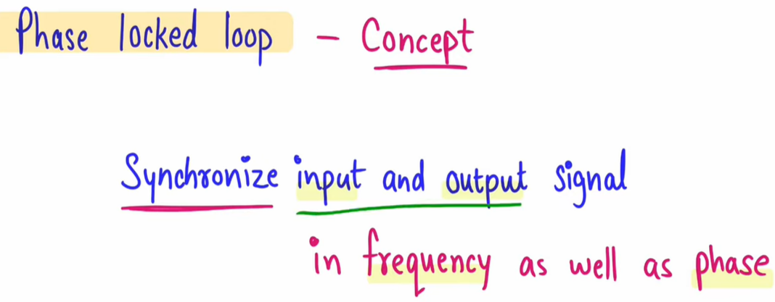

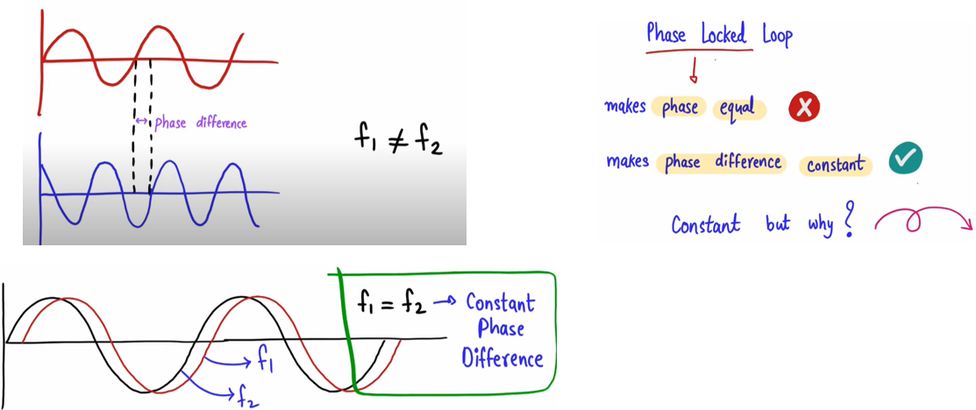

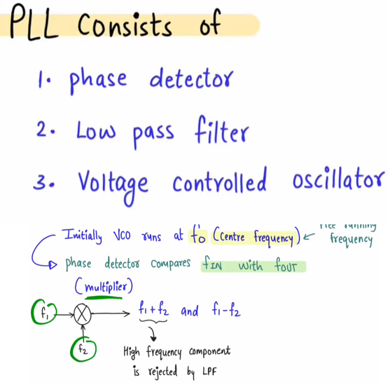

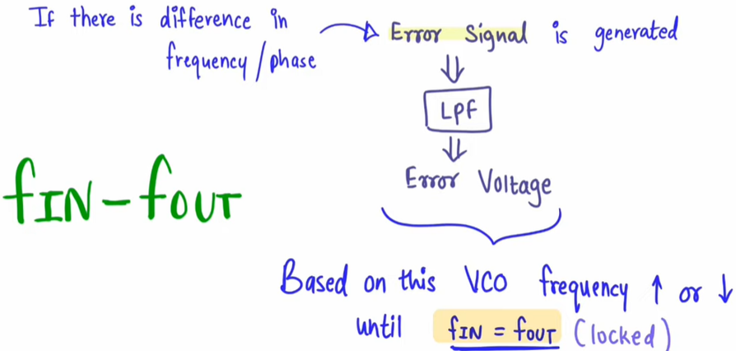

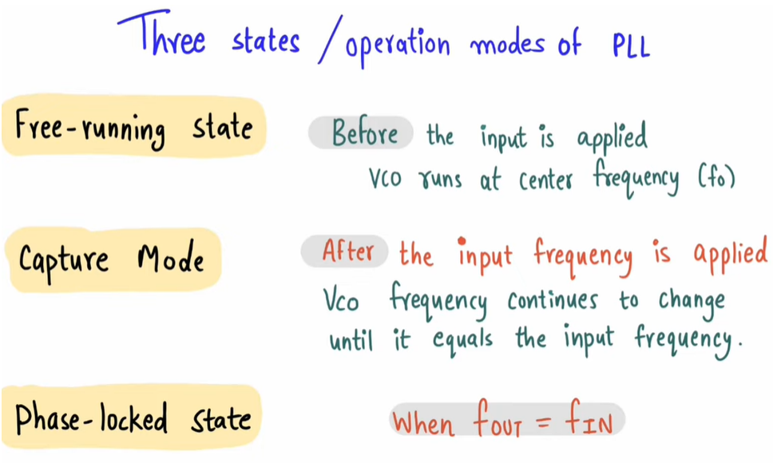

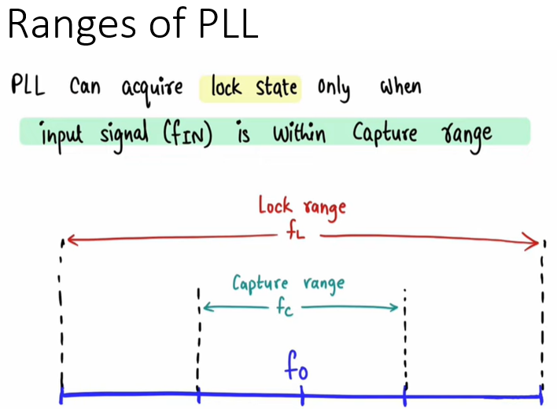

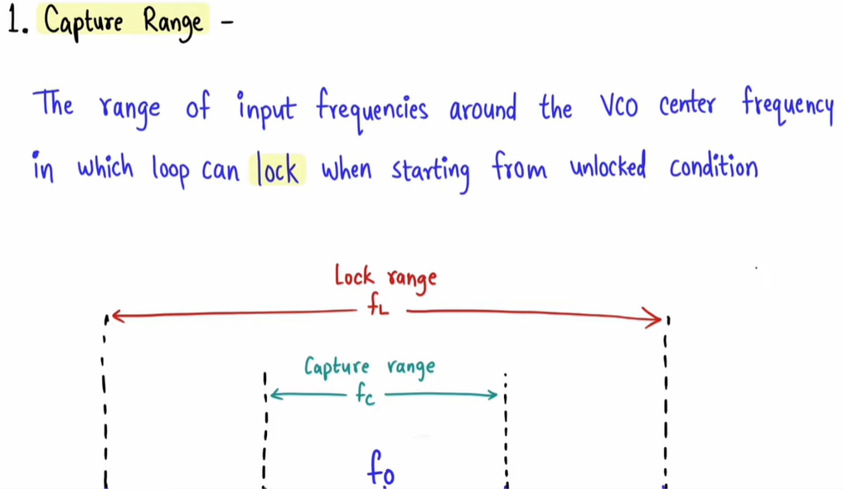

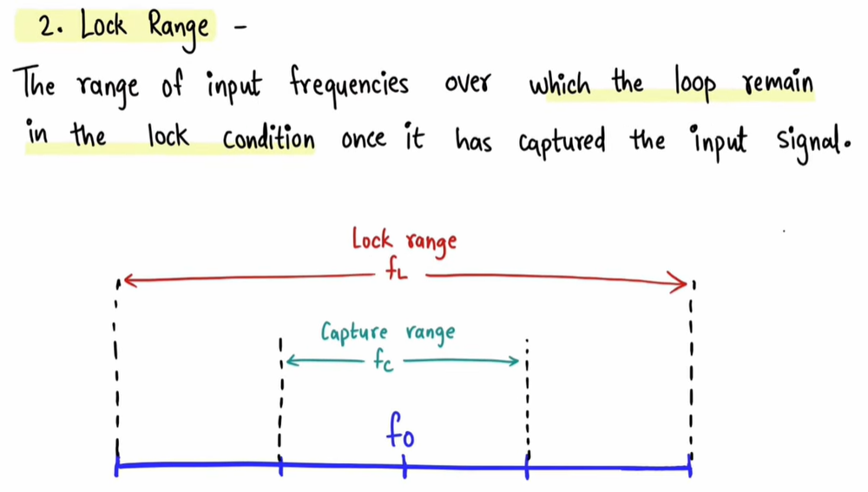

Tuned radio frequency receiver

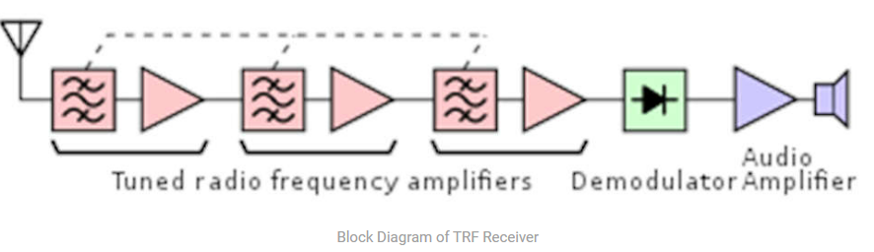

TRF is a type of radio receiver that is controlled by one or more RF amplifier stages followed by a detector circuit to extract the audio signal and usually an audio frequency amplifier.

Early models could be uninteresting to operate because when tuning in a station each stage had to be individually adjusted to the station’s frequency.

But now latest models had ganged tuning, the tuning mechanisms of all stages being linked together, and operated by just one control knob.

In the 1930’s it was replaced by the superheterodyne receiver

* It consisted of three section RF amplifier, demodulator, and audio amplifier.
* The signal received from the antenna is weak and noisy so this signal is given to a broadband RF amplifier.
* This RF amplifier enhances the signal-to-noise ratio and amplifies the signal. Then this signal passed through AM detector or demodulator.
* The output of AM detector or demodulator is an audio signal. The detected audio signal is then amplified by the audio power amplifier.
* The audio amplifier output give to the speaker and then it finally produces the sound.
* The RF amplifier is tuned to a specific frequency that is to be received. Hence if another frequency is to receive, then another TRF receiver should be used.
* By using the RF amplifier tuned to a wide range of frequencies this problem is solved. But this reduces the selectivity of the receiver.
* Advantages of TRF Receiver
* Simplest type of receiver since it does not involve mixing and IF operation.
* Very much suitable to receive single frequency.
* TRF receivers have good sensitivity.
* Disadvantages of TRF Receiver
* Bandwidth changes with center frequency, when the TRF receiver is used to receive a wide range of frequencies.
* Multiple stages of RF amplifiers are used. This can lead to instability since they all are tuned to the same center frequency. Hence stagger tuning is to be used.
* The gain of the TRF receiver is not uniform over a wide range of frequencies.
* Application of TRF Receiver
* It was used in the early days of wire-less technology but it is rarely used today as other techniques offering much better performance are available.
* Limitations of TRF Receiver
* It suffers from variations in BW over the tuning range ( s 40 – 1650 kHz).
* The gain of TRF RX is not uniform over the tuning range.
* The TRF is unstable at high frequency.
* Gang tuning of more capacitors simultaneously is difficult.

Drawback of TRF

* Due to Rf amplifier oscillate at higher frequency, small portion of output leak back to the input create positive feedback and oscillation, create coupling capacitance In power supply not good for receiver.
* Due to enforced used of single tuned crt. Selectivity is poor
* Bandwidth variation over higher range

Superheterodyne Receiver

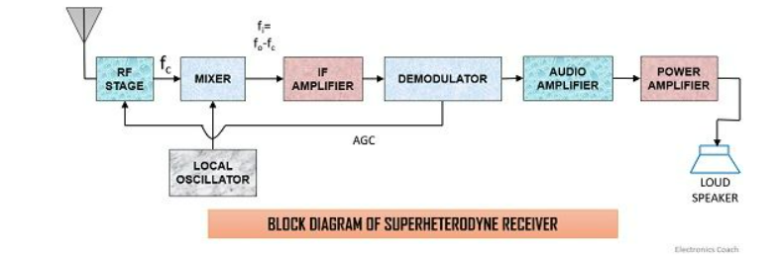

* Definition: Superheterodyne receiver works on the principle of heterodyning which simply means mixing. It is a type of receiver which mixes the received signal frequency with the frequency of the signal generated by a local oscillator.
* The output of mixer provides a lower fixed frequency also known as intermediate frequency. These receivers are called Superheterodyne receivers as the frequency of the signal generated by the local oscillator is more than the frequency of the received signal.

Working of Superheterodyne Receiver

* receiving antenna: The receiving antenna receives the signal which was sent by the transmitter. It sends the received signal for further processing.
* RF amplifier: The received signal is fed to the RF amplifier stage so as to amplify it, as the signal gets attenuated during long-distance transmission. It is tuned in such a way that it can choose the desired carrier frequency and amplify it.
* Local Oscillator: This circuit basically generates a signal with a fixed frequency and the output is then fed to the mixer. When we talk about AM broadcast system, the intermediate frequency is 455 KHz that simply means that local oscillator should select such a frequency which is 455 KHz above the incoming signal frequency.
* Mixer: A mixer simply mixes the carrier frequency with the frequency of the signal generated by the local oscillator.
* Here, two different frequencies are to be mixed so as to have another frequency component of lower value. Now the thing that first comes to our mind is why the mixer produces a lower frequency value, which is the difference between the two frequencies. The summation of the carrier and local oscillator frequency at the output of the mixer will give rise to image frequency which is treated as a type of noise or distortion in the signal. This is the reason why the mixer generates a frequency difference at its output. This difference frequency is a constant value irrespective of the variations in the input, known as the intermediate frequency.



* The constant frequency at its output is gained by capacitance tuning. In capacitance tuning, several capacitances are arranged together and operated by a controlling knob.It doesn’t matter what the incoming signal frequency is, the RF amplifier and local oscillator must be tuned to it.
* IF amplifier: This section basically amplifies the output of the mixer. IF amplifier provides sensitivity(gain) and selectivity (bandwidth requirement) to the receiver. As it consists of several transformers consisting of pairs of the tuned circuit.Here, the sensitivity and selectivity are uniform and does not show variations as in case of TRF receivers because IF amplifier’s characteristics are independent of that of the received signal frequency as it works on the intermediate frequency.  
    
  Due to this, the system design is quite easy so as to provide constant bandwidth along with high gain.This section has narrow bandwidth and due to its lower bandwidth, it rejects all other frequency so as to reduce the risk generated from interference.The lower bandwidth accepting nature supports Superheterodyne receivers to give much better performance than other types of receivers.
* Demodulator: Demodulator is placed exactly after the IF amplifier so that the constant frequency signal is demodulated and the message signal can be extracted from it.
* Audio amplifier: The original signal is fed to the audio amplifier which does not hold distortion or noise so that it can amplify audio signal to a particular level.
* Power amplifier: Here, the signal is further amplified to a particular power level which can activate the loudspeaker. The amplified signal is finally fed to the loudspeaker circuit which converts the electrical form of the signal into an audio sound signal which can be heard by the listeners.

Double spotting

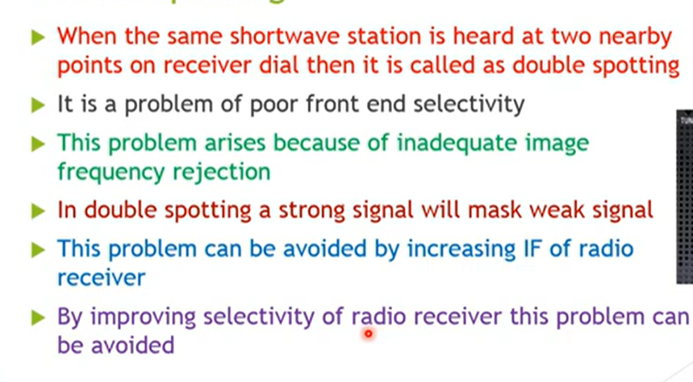

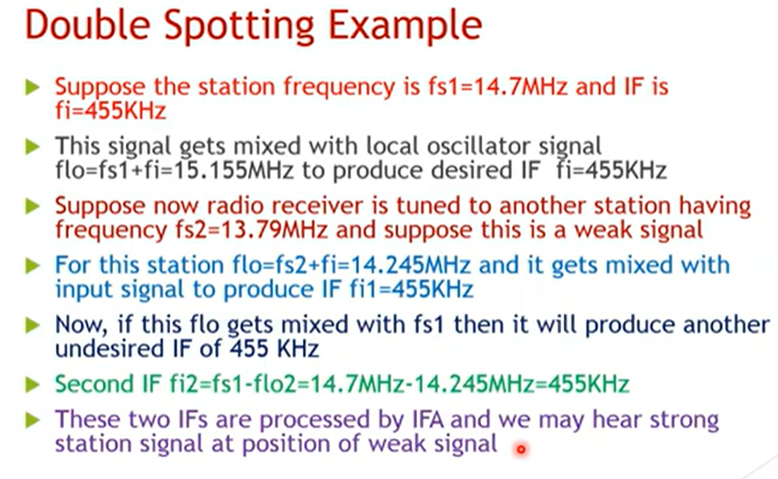

Image rejection ratio

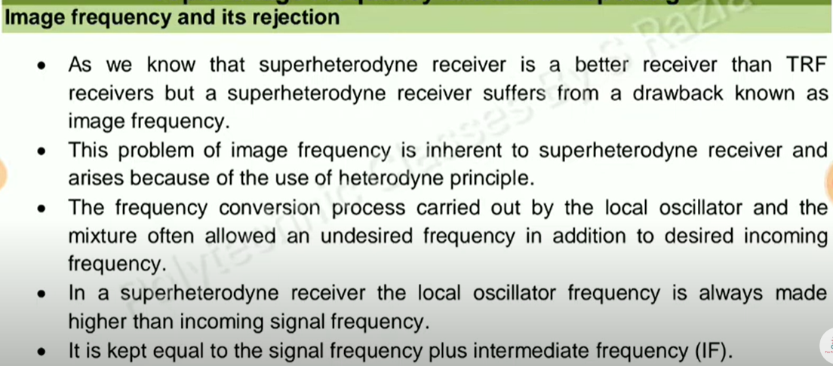

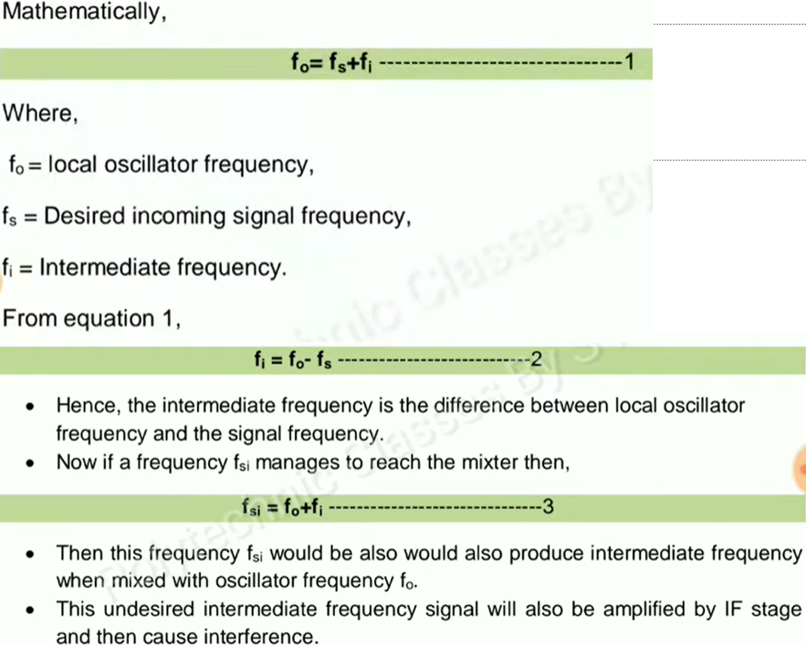

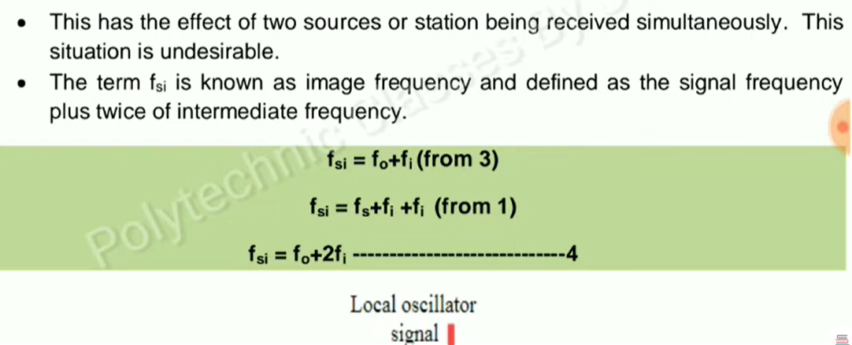

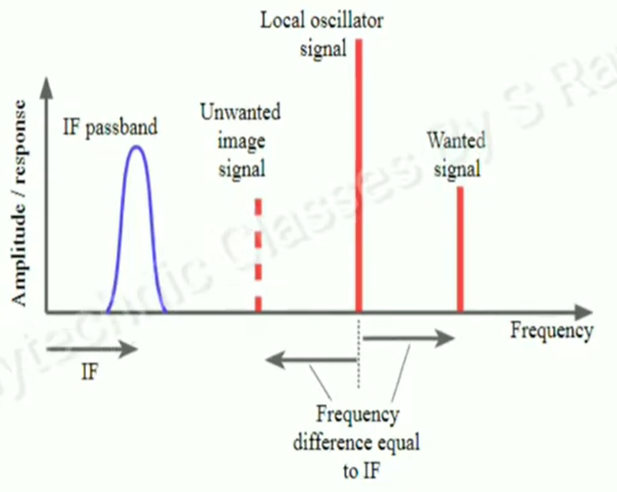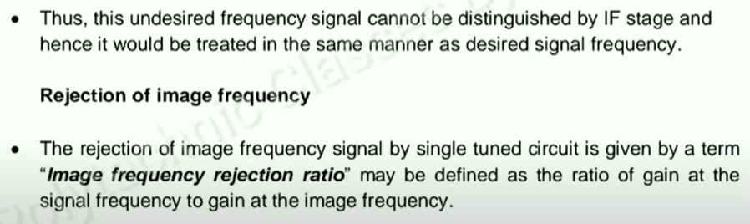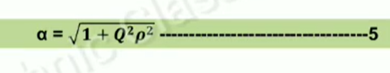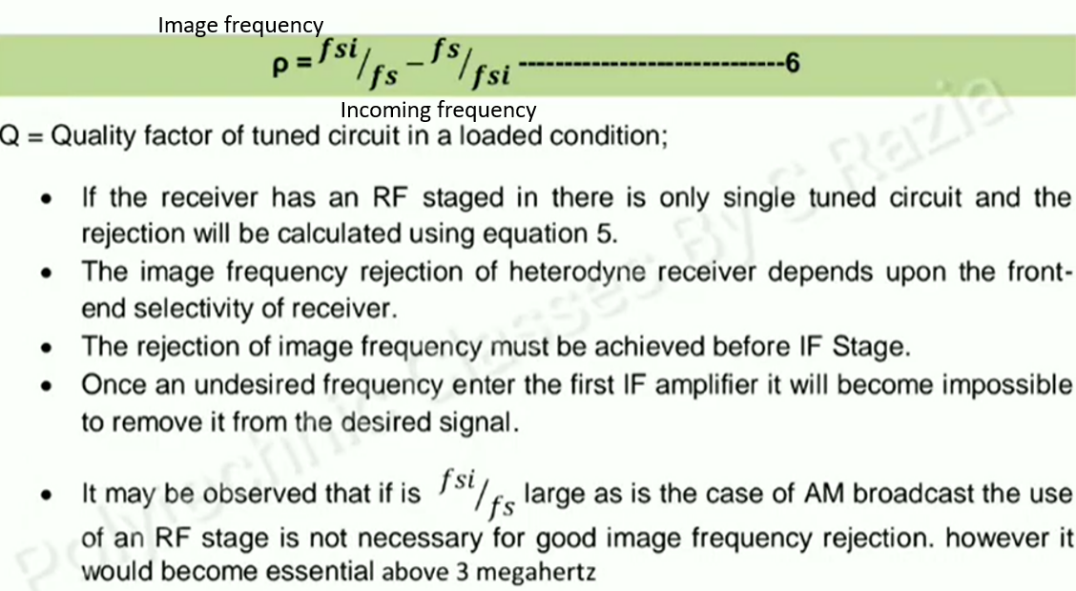

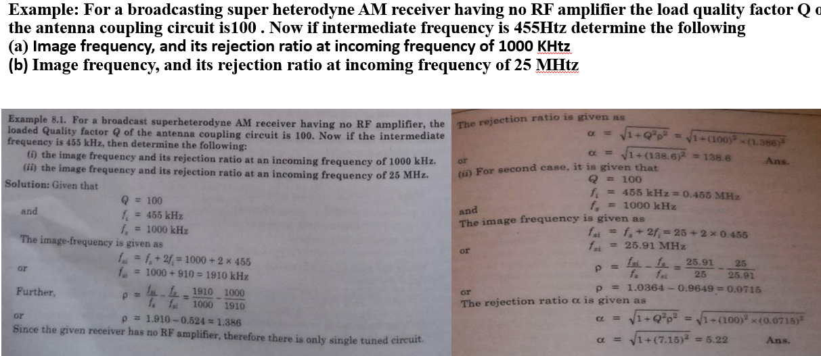

Effect of Feedback on Performance of AM

* Generally, negative feedback is provided in AM transmitters. This negative feedback reduces the distortion in a class-C modulator system. It also linearizes the output of the class-C modulator.
* The negative feedback circuitry samples the RF signal send to the antenna. This sample signal is demodulated by linear demodulator to produce feedback signal.
* Tuned class-C amplifier must provide sufficient power gain to drive the final power amplifier.
* Antenna systems for AM transmitters must be located at some point remote from the studio operations.

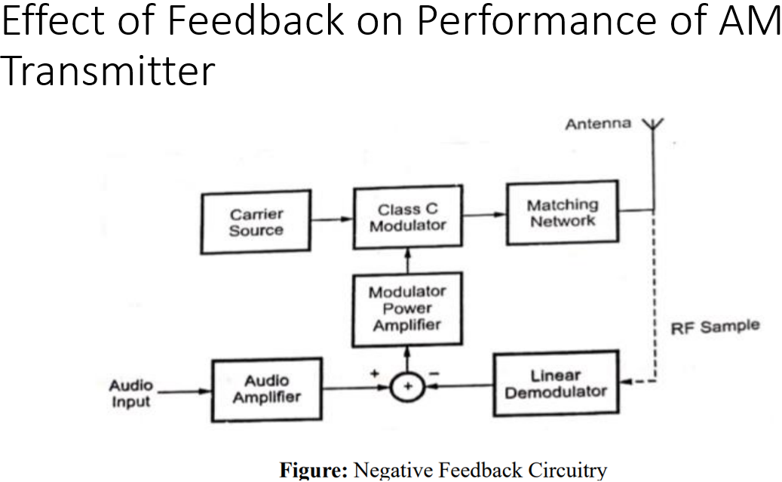

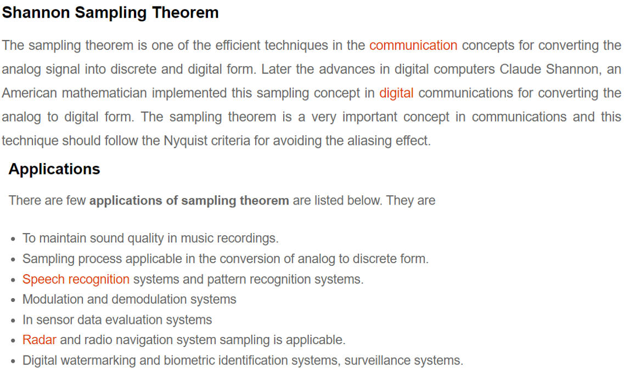

Types of sampling techniques

* There are three types of sampling techniques:
* Impulse sampling.
* Natural sampling.
* Flat Top sampling.

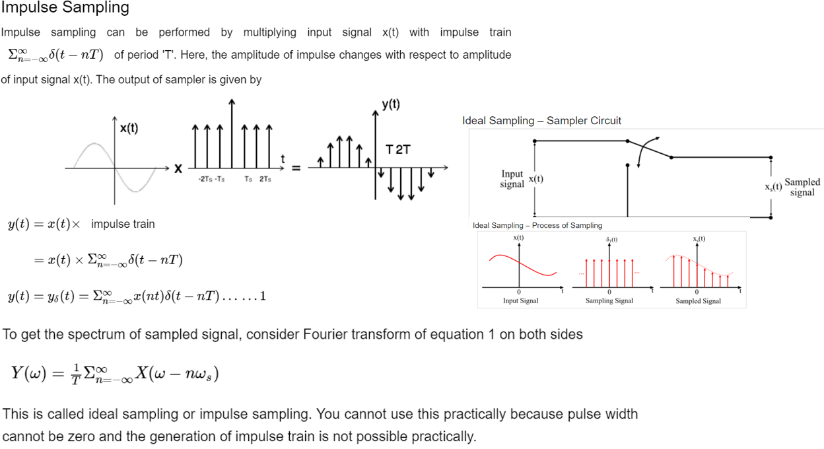

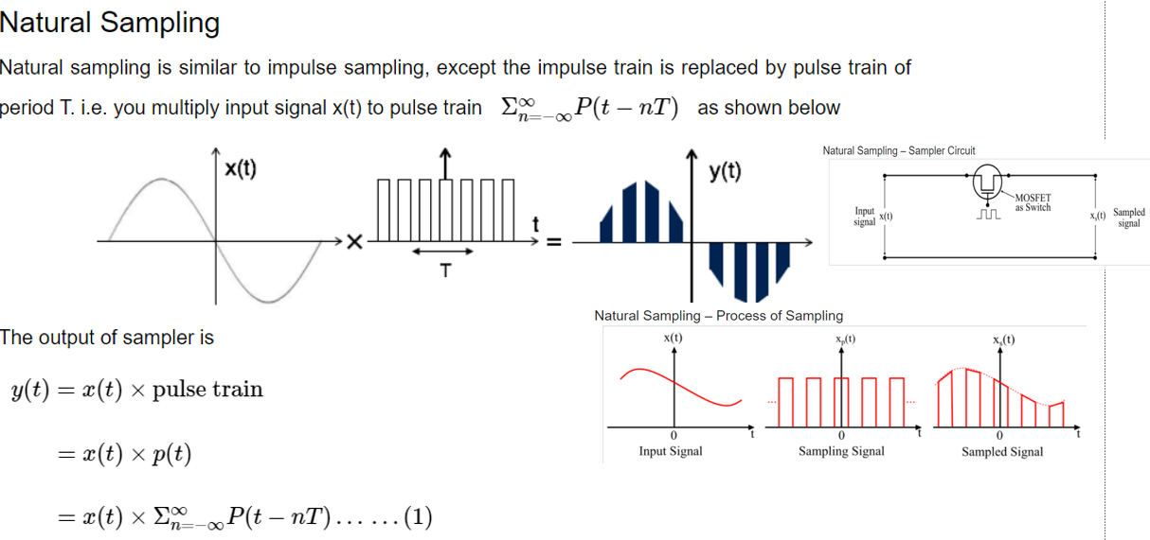

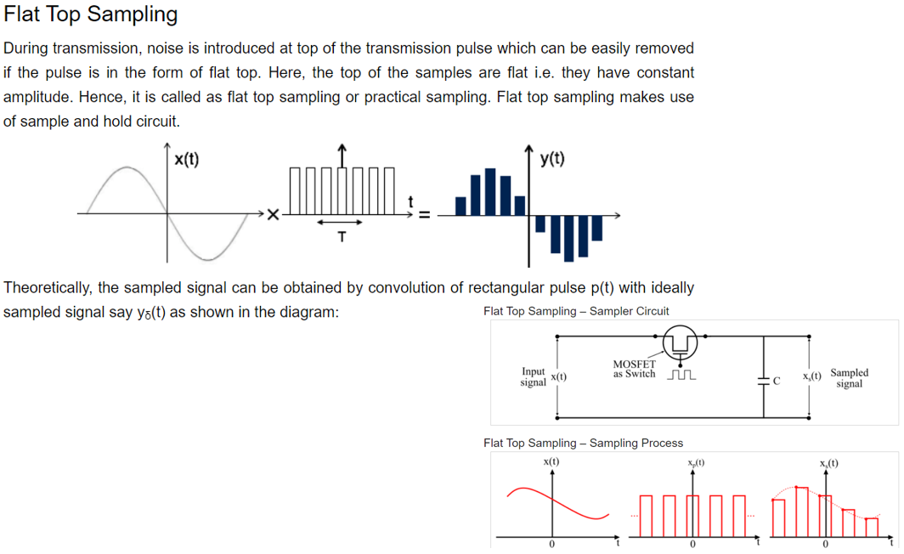

Types of Quantization

* There are two types of Quantization –
* Uniform Quantization and Non-uniform Quantization.
* The type of quantization in which the quantization levels are uniformly spaced is termed as a Uniform Quantization. The type of quantization in which the quantization levels are unequal and mostly the relation between them is logarithmic, is termed as a Non-uniform Quantization.
* There are two types of uniform quantization. They are Mid-Rise type and Mid-Tread type. The following figures represent the two types of uniform quantization.

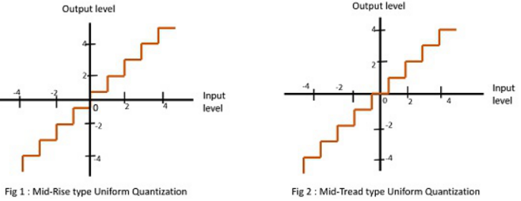

Figure 1 shows the mid-rise type and figure 2 shows the mid-tread type of uniform quantization.

* The Mid-Rise type is so called because the origin lies in the middle of a raising part of the stair-case like graph. The quantization levels in this type are even in number.
* The Mid-tread type is so called because the origin lies in the middle of a tread of the stair-case like graph. The quantization levels in this type are odd in number.
* Both the mid-rise and mid-tread type of uniform quantizers are symmetric about the origin.

Pulse Width Modulation

* In power electronics, pulse width modulation is a proven effective technique that is used to control semiconductor devices. Pulse width modulation or PWM is a commonly used control technique that generates analog signals from digital devices such as microcontrollers. The signal thus produced will have a train of pulses, and these pulses will be in the form of square waves. Thus, at any given time, the wave will either be high or low. Let us learn more about pulse width modulation in this article.
* How is a Pulse Width Modulation Signal generated?
* A pulse width modulating signal is generated using a comparator. The modulating signal forms one part of the input to the comparator, while the non-sinusoidal wave or sawtooth wave forms the other part of the input. The comparator compares two signals and generates a PWM signal as its output waveform. If the sawtooth signal is more than the modulating signal, then the output signal is in a “High” state. The value of the magnitude determines the comparator output which defines the width of the pulse generated at the output
* 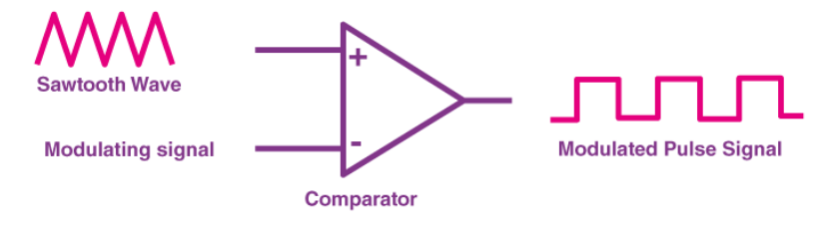
* Applications of Pulse Width Modulation
* Due to the high efficiency, low power loss, and the PWM technique’s ability to precisely control the power, the technique is used in a variety of power applications. Some of the applications of PWM are as follows:
* The pulse width modulation technique is used in telecommunication for encoding purposes.
* The PWM helps in voltage regulation and therefore is used to control the speed of motors.
* The PWM technique controls the fan inside a CPU of the computer, thereby successfully dissipating the heat.
* PWM is used in Audio/Video Amplifiers.
* Advantages and Disadvantages of Pulse Width Modulation
* First, let us talk about the advantages of the pulse width modulation technique before discussing its disadvantages:
* PWM technique prevents overheating of LED while maintaining its brightness.
* PWM technique is accurate and has a fast response time.
* PWM technique provides a high input power factor.
* PWM technique helps motors generate maximum torque even when they run at lower speeds.
* The above were some of the advantages of the Pulse width modulation technique, now let us look at some of the disadvantages:
* As the PWM frequency is high, switching losses are considerably high.
* It induces Radio Frequency Interference (RFI).

Working in notes

Pulse Position Modulation (PPM)

* Definition: A modulation technique that allows variation in the position of the pulses according to the amplitude of the sampled modulating signal is known as Pulse Position Modulation (PPM). It is another type of PTM, where the amplitude and width of the pulses are kept constant and only the position of the pulses is varied.
* Simply put, the pulse displacement is directly proportional to the sampled value of the message signal.
* To understand the generation of the PPM signal, it is necessary to understand Pulse Width Modulation (PWM or PDM). PWM is the first type of PTM and is discussed in the previous content.
* Basics of Pulse Position Modulation
* The information is transmitted with the varying position of the pulses in pulse position modulation.
* The basic idea about the generation of a PPM waveform is that here, as the amplitude of the message signal increases, the pulse shifts according to the reference.
* As we have already discussed in PWM that due to the variable width of the pulses, the transmission power also varies accordingly. However, this is not the case with PPM as here the width of the pulses remains constant and only their position varies. Thus, transmission power does not show variation.
* Now, the question arises how the position of the pulses show variation?
* As we have already discussed that a PPM signal is generated in reference to a PWM signal. Thus, the trailing edge of the PWM signal acts as the beginning point of the pulses of PPM signal.
* Block diagram for generation of PPM signal
* As we have already discussed that a PPM signal can be easily generated by making use of a PWM signal. Thus, here we have assumed that a PWM signal is already generated at the output of the comparator and now we have to generate a PPM signal.
* The figure below shows the block diagram for generating a PPM signal

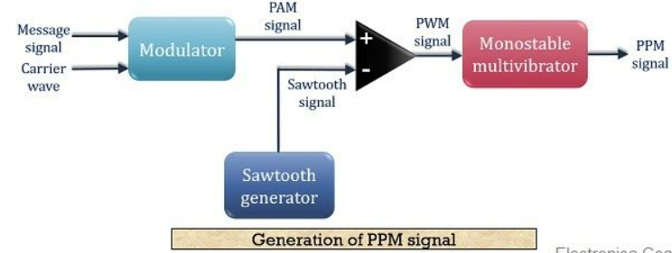

Here, we have made a detailed block diagram where first, a PAM signal is produced with is further processed at the comparator in order to generate a PWM signal.

The output of the comparator is fed to a monostable multivibrator. It is negative edge triggered. Hence, with the trailing edge of the PWM signal, the output of the monostable goes high.

This is why a pulse of PPM signal begins with the trailing edge of the PWM signal.

It is to be noted in case of PPM that the duration for which the output will be high depends on the RC components of the multivibrator. This is the reason why a constant width pulse is obtained in case of the PPM signal.

With the modulating signal, the trailing edge of PWM signal shifts, thus with that shift, the PPM pulses shows shifts in its position.



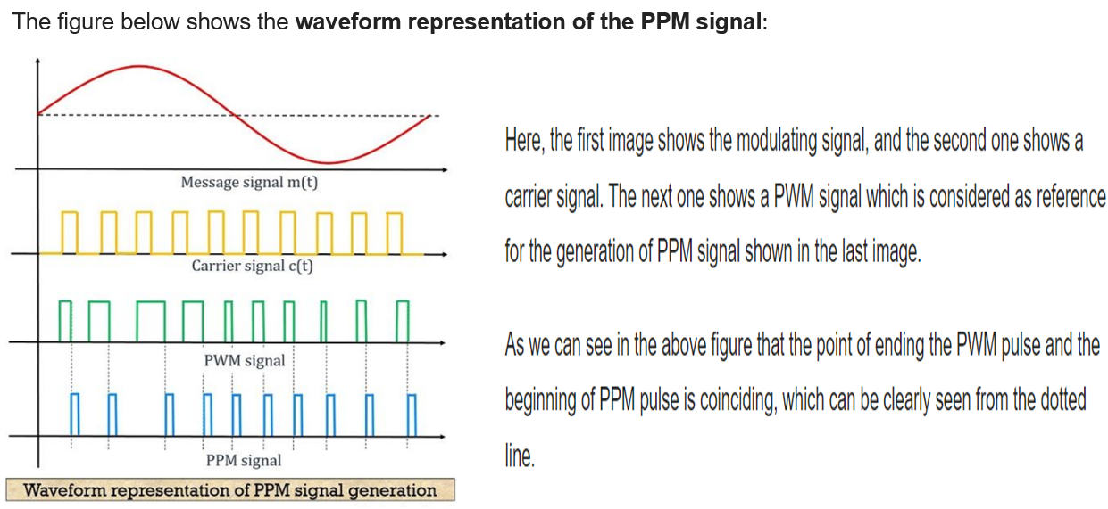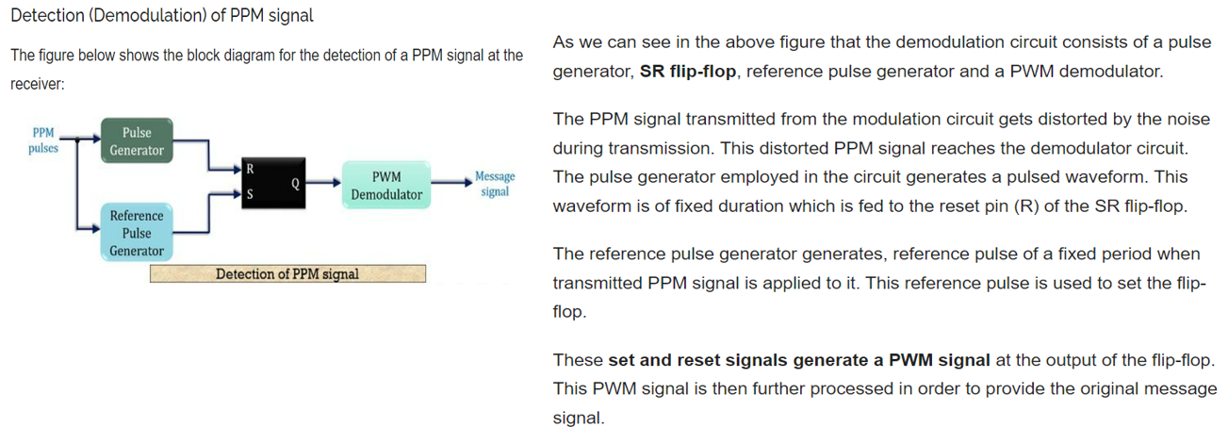

Advantages of Pulse Position Modulation

1. Similar to PWM, PPM also shows better noise immunity as compared to[PAM](https://electronicscoach.com/pulse-amplitude-modulation.html). This is so because information content is present in the position of the pulses rather than amplitude.
2. As the amplitude and width of the pulses remain constant. Thus the transmission power also remains constant and does not show variation.
3. Recovering a PPM signal from distorted PPM is quite easy.
4. Interference due to noise in more minimal than PAM and PWM.

Disadvantages of Pulse Position Modulation

1. In order to have proper detection of the signal at the receiver, transmitter and receiver must be in synchronization.
2. The bandwidth requirement is large.

Applications of Pulse Position Modulation

The technique is used in an optical communication system, in radio control and in military applications.

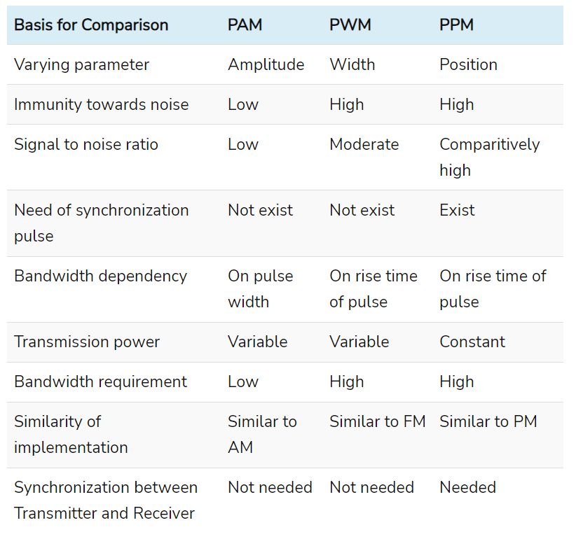

T-1 Carrier

* What Does T-1 Carrier Mean?
* A T-1 carrier is a dedicated telephone connection or a time-division-multiplexed digital transmission service that supports a data rate of 1.544 Mbps. A T-1 line generally includes 24 separate channels, each of which is able to support 64 Kbps. Every 64 Kbps channel is often customized to transport voice or data traffic. The majority of telephone companies only allow the purchase of a few of the individual channels, referred to as fractional T-1 access
* The T-carrier systems are totally digital and use time-division multiplexing (TDM) and pulse code modulation (PCM). The original T carrier system was developed by Bell Labs in the early 1960s.

T-1 is the method that is conventionally used by the telephone companies for transporting digitized telephone communication among central offices. Since the 1960s, a single T-1 channel was able to carry 24 high-quality voice conversations. Because T-1 is fully digital, it eradicates the chance of crosstalk, which is typical among analog carrier networks where the copper pairs tend to pick up transmissions from neighboring pairs.

A T-1 physically includes two twisted pairs of copper wire. The pairs use a full-duplex configuration in which one pair sends information while the other receives information.

There are two main framing standards used by a T-1 carrier line:

* D4 framing is the main framing standard, which was primarily used in combination with T1 networks.
* Another framing method used in T-1 is the relatively new Extended Super Frame (ESF). ESF makes use of fewer framing bits compared to D4 and offers the best way of obtaining performance data from T-1.

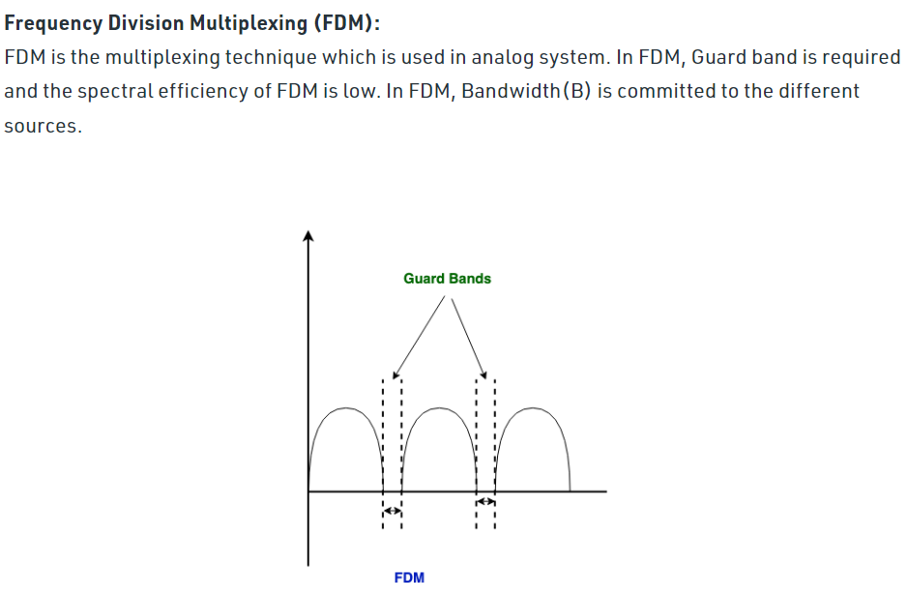

Frequency division multiplexing (FDM) is a technique of multiplexing which means combining more than one signal over a shared medium. In FDM, signals of different frequencies are combined for concurrent transmission.

Concept and Process

In FDM, the total bandwidth is divided to a set of frequency bands that do not overlap. Each of these bands is a carrier of a different signal that is generated and modulated by one of the sending devices. The frequency bands are separated from one another by strips of unused frequencies called the guard bands, to prevent overlapping of signals.

The modulated signals are combined together using a multiplexer (MUX) in the sending end. The combined signal is transmitted over the communication channel, thus allowing multiple independent data streams to be transmitted simultaneously. At the receiving end, the individual signals are extracted from the combined signal by the process of demultiplexing (DEMUX).

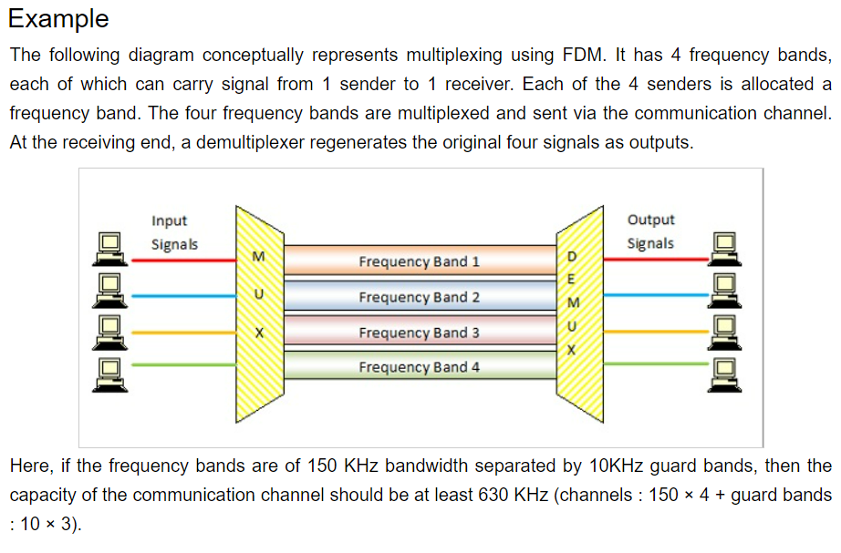

Uses and Applications

It allows sharing of a single transmission medium like a copper cable or a fiber optic cable, among multiple independent signals generated by multiple users.

FDM has been popularly used to multiplex calls in telephone networks. It can also be used in cellular networks, wireless networks and for satellite communications.

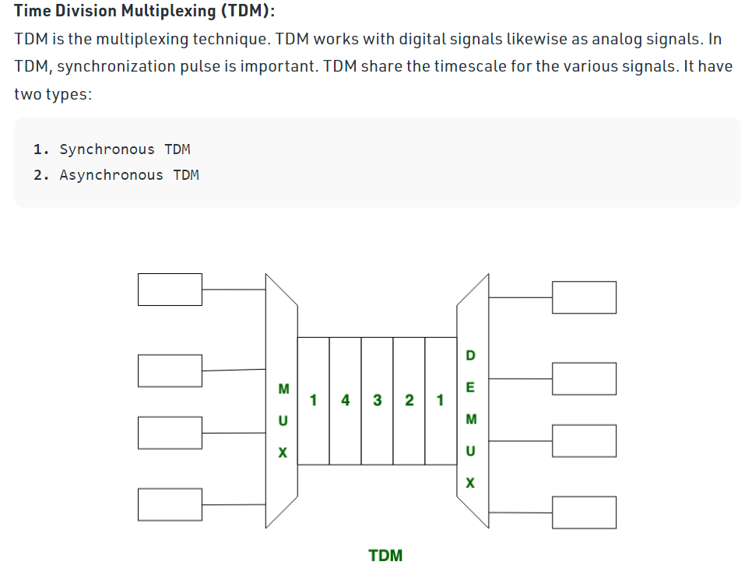

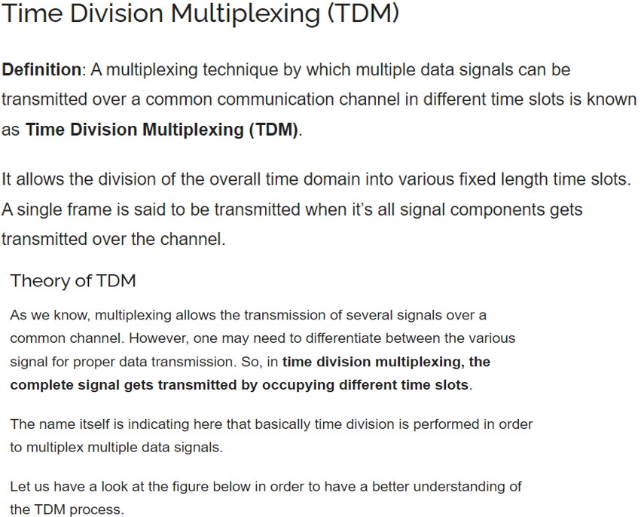

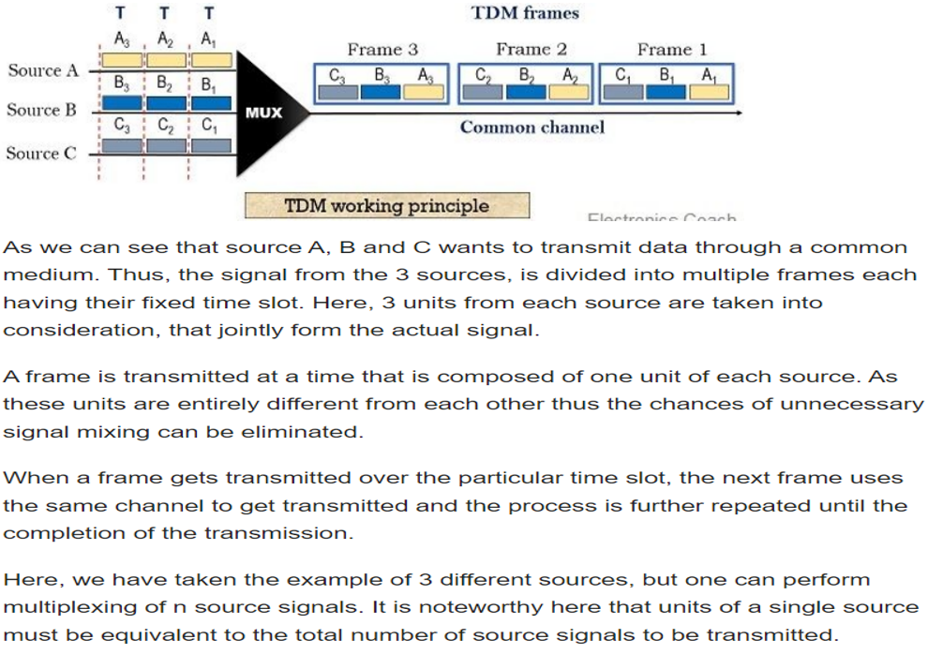

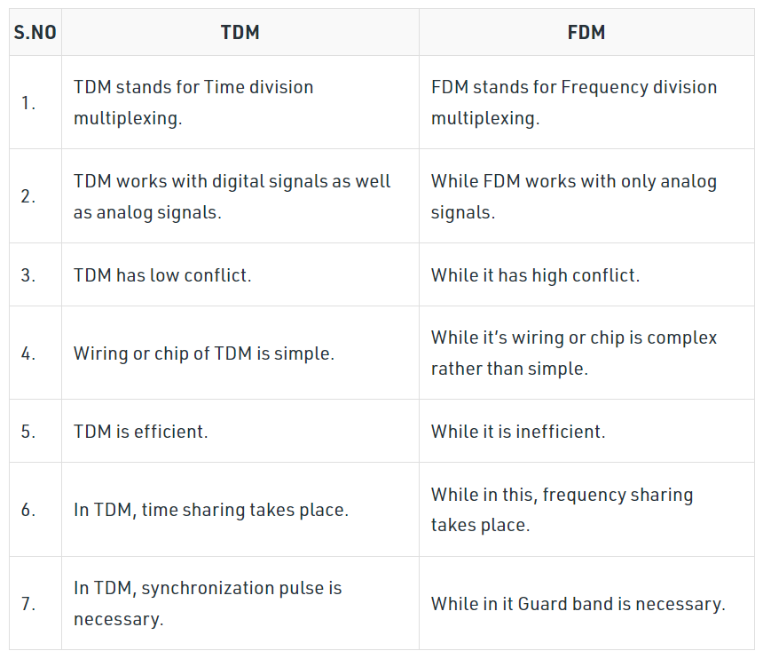

FM Generation

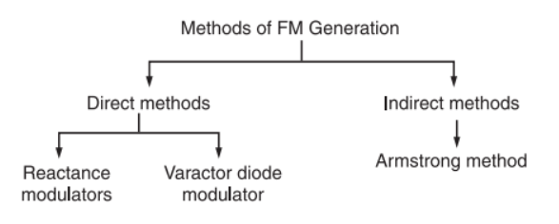

**Varactor diode method/varactor diode method**

**Explain in your own words**

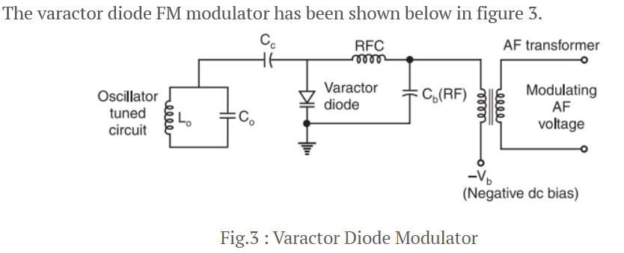 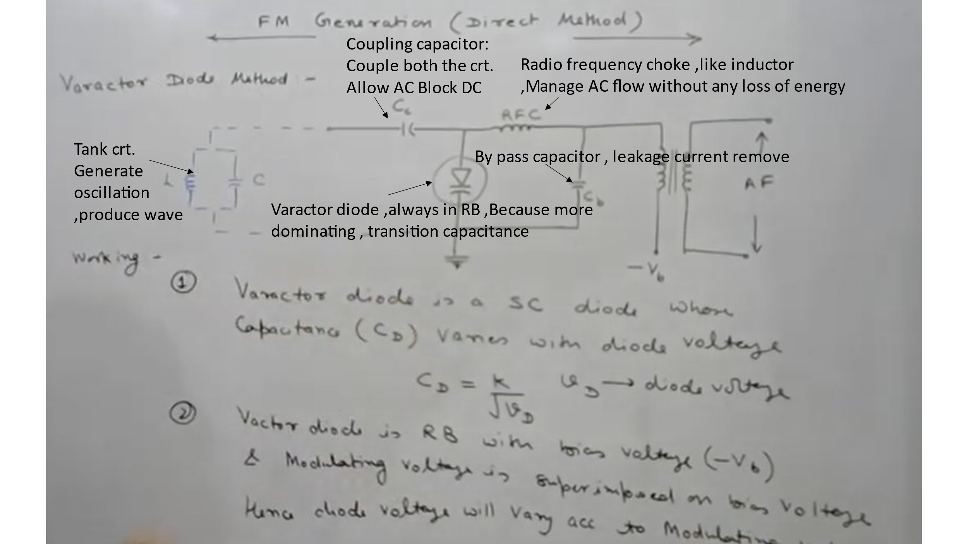 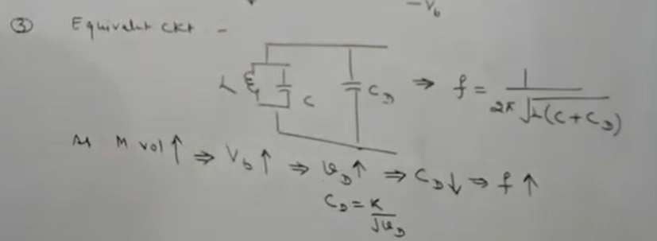 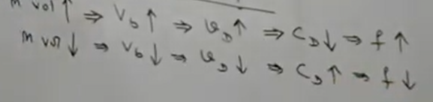 Working Operation

The varactor diode is reverse biased by the negative dc source  –Vb.

The modulating AF voltage appears in series with the negative supply voltage. Hence, the voltage applied across the varactor diode varies in proportion with the modulating voltage.

This will vary the junction capacitance of the varactor diode.

The varactor diode appears in parallel with the oscillator tuned circuit.

Hence the oscillator frequency will change with change in varactor dioide capacitance and FM wave is produced.

The RFC will connect the dc and modulating signal to the varactor diode but it offers a very high impedance at high oscillator frequency. Therefore, the oscillator circuit is isolated from the dc bias and modulating signal.

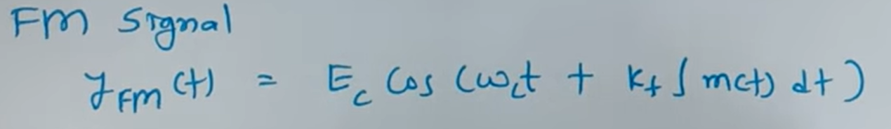 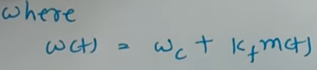 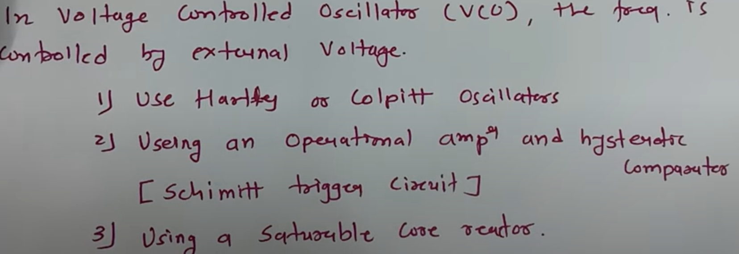 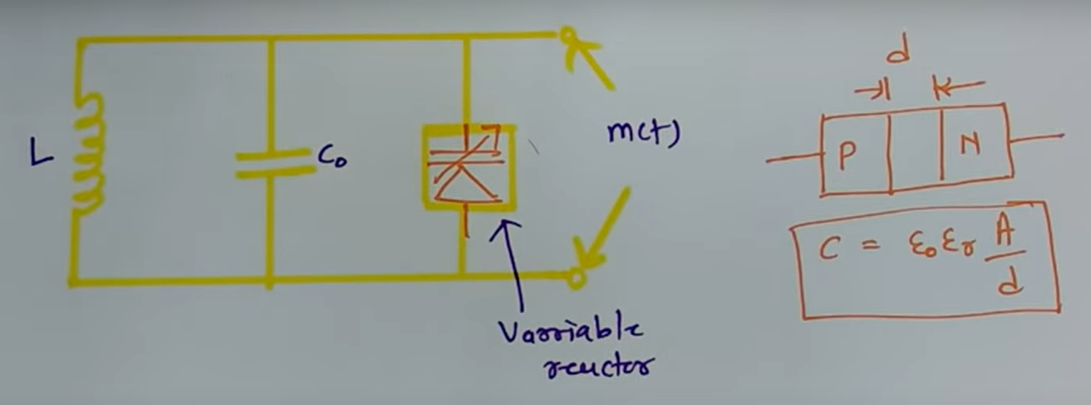

Indirect methord of FM generation

* **Drawback of direct method**
* Not Stable using Tank crt. Broad casting not possible

Using crystal oscillator instead of LC oscillator

* Because Varactor diode is nonlinear so large distortion in direct gen method

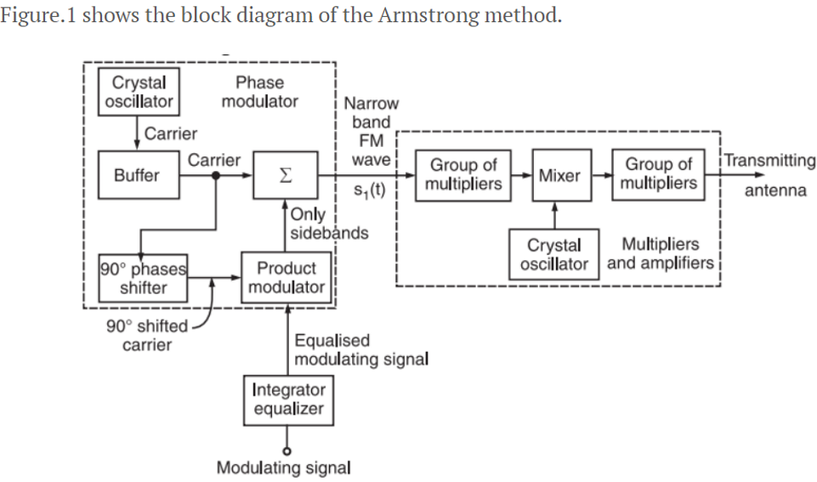

**Working Principle**

* The working operation of this system can be divided into two parts as follows:
* **Part I: Generate a narrow band FM wave using a phase modulator.**
* **Part II: Use the frequency multipliers and mixer to obtain the required values of frequency deviation, carrier and modulation index.**

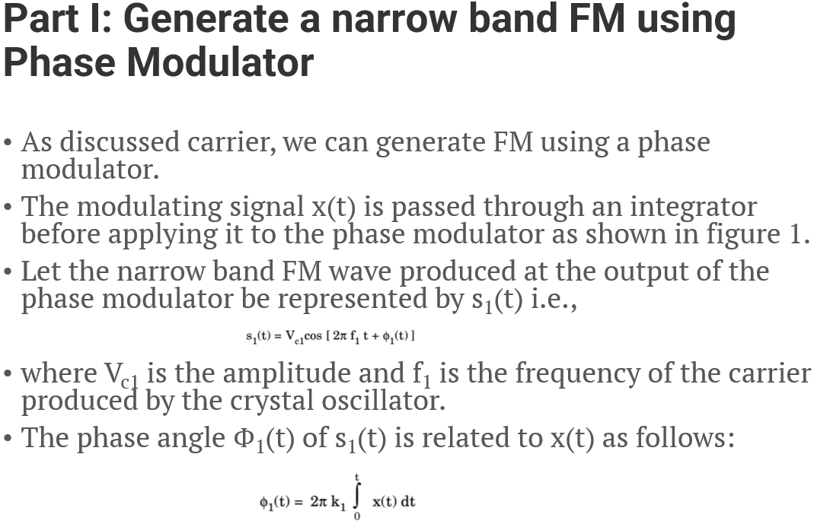 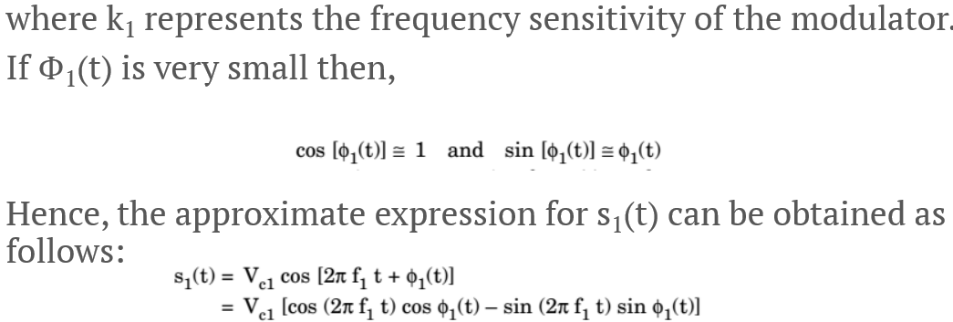 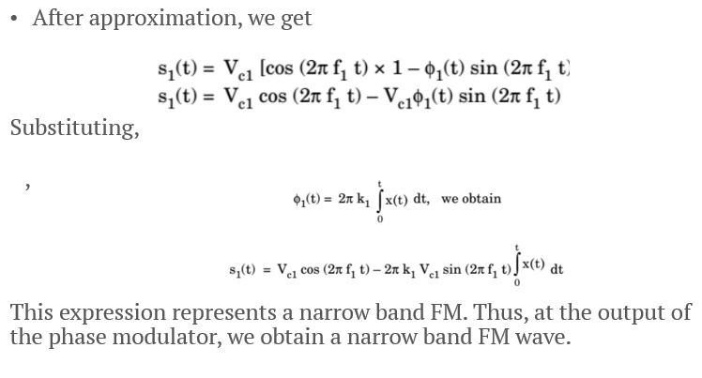 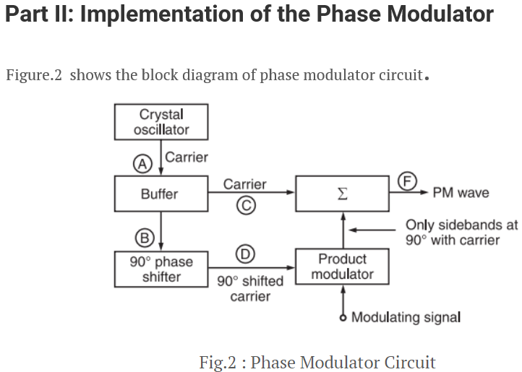

**Working Principle**

* The crystal oscillator produces a stable unmodulated carrier which is applied to the 90° phase shifter as well as the combining network through a buffer.
* The 90° phase shifter produces a 90° phase shifted carrier. It is applied to the balanced modulator along with the modulating signal.
* Thus, the carrier used for modulation is 90° shifted with respect to the original carrier.
* At the output of the product modulator, we get DSB SC signal i.e., AM signal without carrier.
* This signal consists of only two sidebands with their resultant in phase with the 90° shifted carrier .
* The two sidebands and the original carrier without any phase shift are applied to a combining network (∑). At the output of the combining network, we get the resultant of vector addition of the carrier and two sidebands as shown in figure 2.

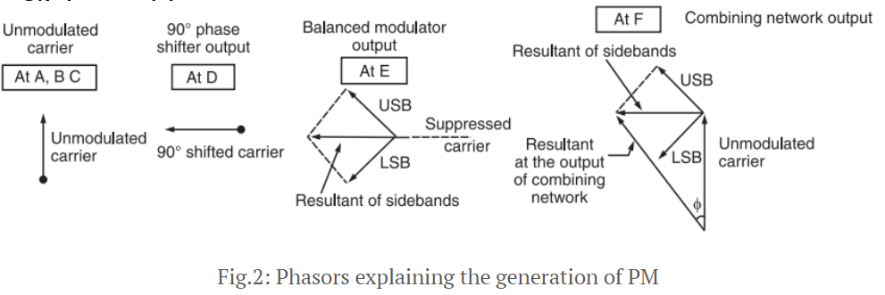

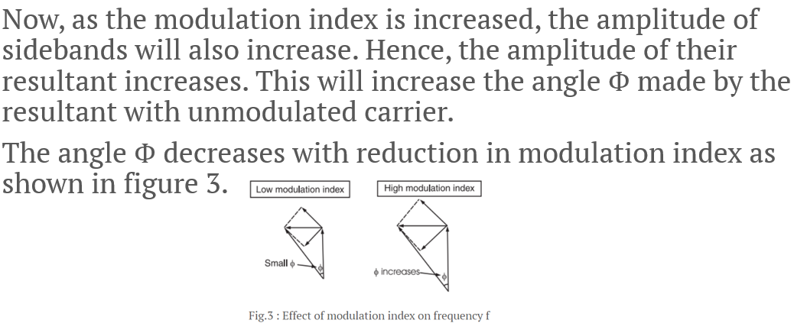

**Part III: Use of Frequency Multipliers Mixer and Amplifier**

* The FM signal produced at the output of phase modulator has a low carrier frequency and low modulation index. They are increased to an adequately high value with the help of frequency multipliers and mixer.

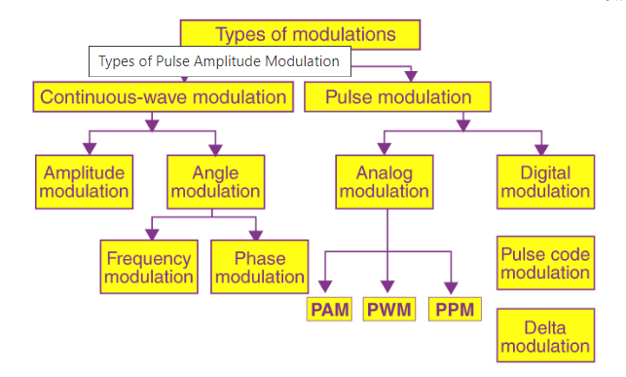

Pulse Amplitude Modulation

* Pulse amplitude modulation is defined as the data transmission by altering the amplitudes (power levels or voltage) of every pulse in a regular time sequence of electromagnetic pulses.
* The possible number of amplitudes can be infinite, but mostly it is some power of two so that the final output signal can be digital. For example, in level-4 PAM there are 22discrete pulse amplitudes; in level-8 PAM there are 23discrete pulse amplitudes.

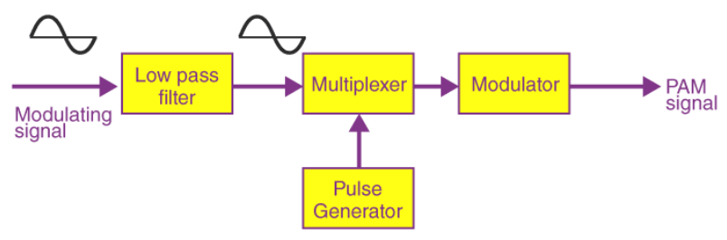

*There are two major types of PAMs:*

* **Single polarity PAM:** Here, an appropriate fixed DC bias is integrated with the signal to assure that all pulses are positive.
* **Double polarity PAM:** Here, the pulses are both negative and positive.

*In some PAMs:*

* The amplitude of every pulse is directly proportional to instantaneous modulating amplitude when the pulse occurs.
* While in other PAM, the amplitude of every pulse is inversely proportional to instantaneous modulating amplitude when at the occurrence of a pulse.

In some other systems, the intensity of every pulse is based on particular characteristics of modulating signals other than strength like instantaneous phase or frequency

* Applications:
* PAM is mostly applied in non-based modulating transmission of digital data and applications replaced by pulse-code modulation and pulse-position modulation.
* Particularly all phone modems faster than 300 bit/s use quadrature amplitude modulation.
* Advantages of Pulse Amplitude Modulation
* PAM allows data to be transmitted more effectively, efficiently and quickly using conventional copper wires in greater volume.
* The frequency modulations available are infinite; hence PAM formulas can be developed continually to allow increased data throughput over existing networks.
* PAM is also the simplest form of modulation.